***Yellow fluffy cat***

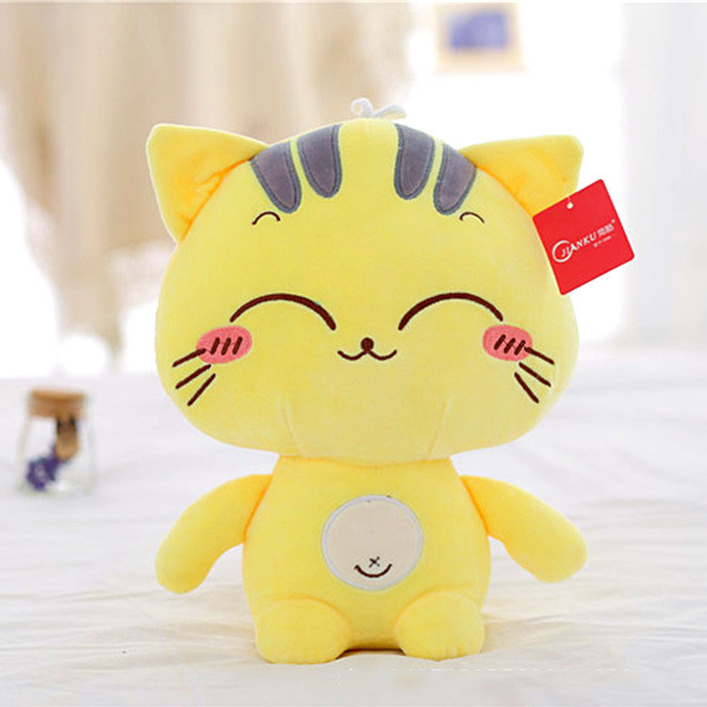

*ellow cotton cat is made from high quality cotton that is safe for users  
  
Various facial expressions are available  
  
Available in sizes 20cm, 60cm and 80cm.  
  
This is a great gift for a girlfriend or child."*